Video FAQ’s

## Types of Cable Connections

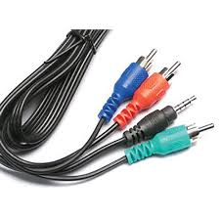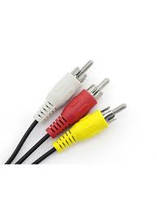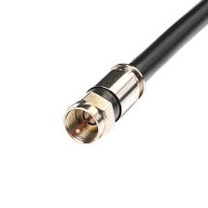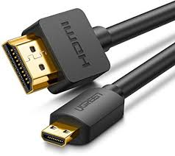**HDMI (Most Common)**  **Component** **RCA** **Coax**

**Ethernet/Cat5**

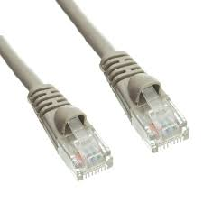

**Blue or Black TV screen that reads “No Signal”:**

This can be caused by a few things. The most common is your TV isn’t on the correct input. Citizens Connected set-top boxes (STB) are usually connected to your TV via a HDMI cable. Below are a few of the most common issues and how to fix them.

**Wrong Input**

1. Verify which type of cable connects your set-top box to your TV.
2. With your TV on, get the remote that came with your TV (LG remote, Samsung, Toshiba, etc.)
3. Locate the “input” or “source” button and press one time to bring up the on-screen input menu
4. Select the correct source for your cable connection

**Bad Cable/Bad port**

1. If your set-top box is connected via HDMI cable, try moving the cable to a different HDMI port on your TV if it has more than one.
2. Change the input on the TV to the new HDMI input i.e. HDMI 2
3. If you still have issues, try a different HDMI cable

**STB is “frozen”**

1. Verify if there are any lights either on the front or the back of the set-top box. If plugged into power, the back should always have a green and an orange light by the ethernet plug.
2. If you see lights, unplug the set-top box from power, count to 10, and plug back in. Service should be restored.
3. If you do not see lights, verify that there is power coming from the outlet. If there is, either the set-top box or power cord is bad.

**Message on screen that reads** “Press OK to watch TV”:

Your set-top box is turned off. Using your Citizens remote, press the STB button on the top right of the remote, then press the power button or the OK button.

**How can I see just my subscribed channels?**

You can find your subscribed channels in “Favorites”, but you need to tell the Guide to remember it. Use your Citizens/Ntera remote to complete the following steps.

1. Press the **STB** button
2. Press the **MENU** button.
3. Arrow down to **SETTINGS**
4. Arrow over to **GUIDE**
5. Press **OK** to bring the guide settings up.
6. Arrow down to **REMEMBER CHANNEL FILTER**.
7. Press the right arrow to change to **YES**.
8. Arrow down to the bottom of the screen and press **OK** to choose **SAVE**.

Then, the next time you are in the guide, choose the Subscribed channel list by using the **BLUE** button on your remote for **Favorites**. Each time you press the BLUE button, your guide changes to a new list. Continue to press the **BLUE** button until you see **SHOWIN SUBSCRIBED CHANNELS** on the bottom left of your screen. Now your set top box will remember that selection anytime you open the guide.

**How do I turn Closed Captioning On/Off?**

To turn Closed Captioning on or off, press the **MENU** button on your remote and choose **SETTINGS**. Then choose **DISPLAY**. Your first option will be **Closed Caption**. Select either **AUTO** or **OFF** by using the left and right arrows by the OK button on your remote. Arrow down to bottom of screen and select **SAVE**.